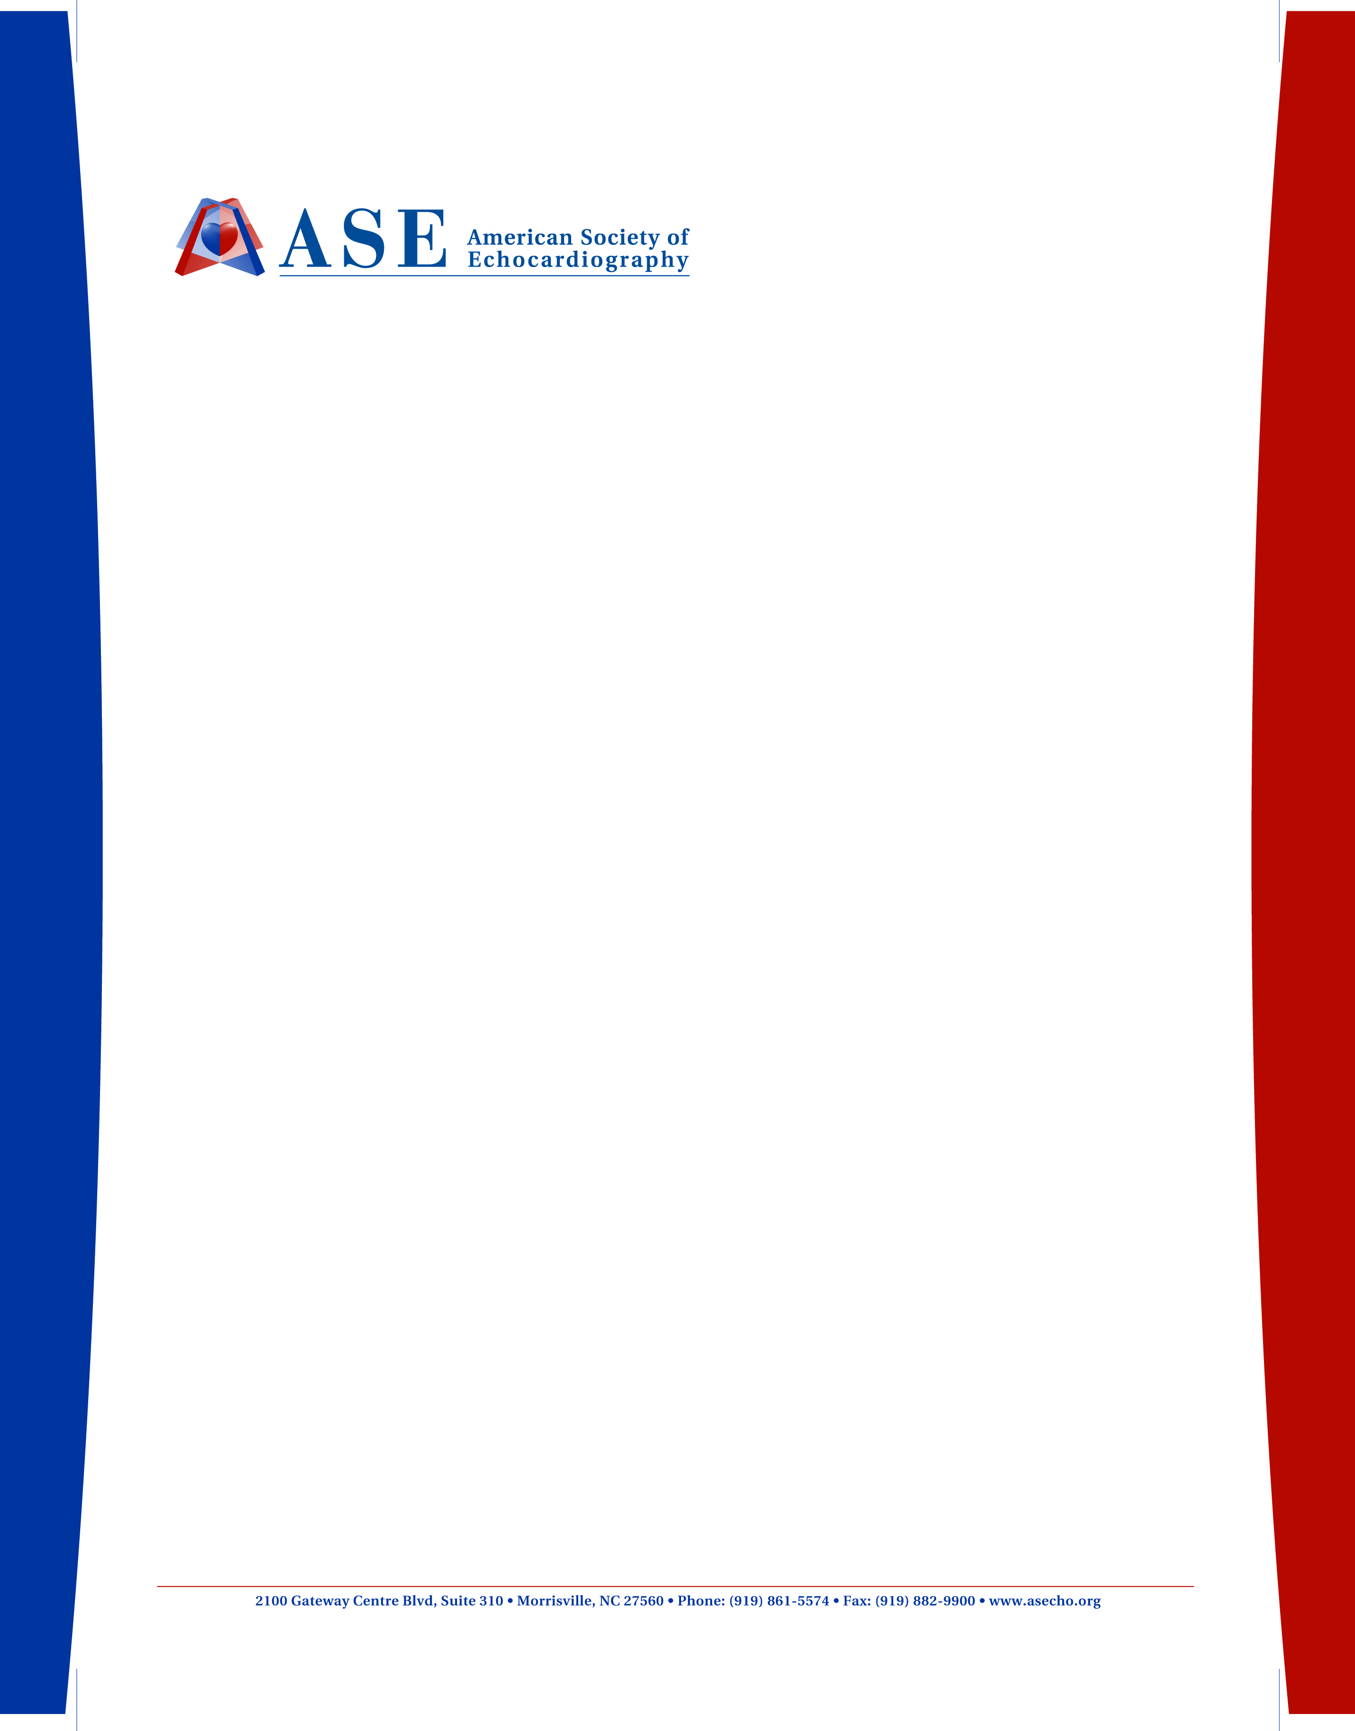

February 2018
This invitation letter is valid for:
Institution:
Address:

On behalf of the American Society of Echocardiography and the Echo ASE ASEAN Program Committee, I invite you to participate in the 3rd Annual Echo ASE ASEAN Conference, to be held in Manila, Philippines on March 22-24, 2018.

International travel may require extra time to arrive and adjust prior to the start of the sessions.

Registration and housing information can be found online at http://asecho.org/asean/. Please note that all expenses related to your attendance, including travel and lodging, are your personal responsibility.

The 3rd Annual Echo ASE ASEAN is a professional education activity, and provides attendees an opportunity to explore emerging issues and developments in the field of cardiovascular ultrasound imaging. We look forward to your attendance and participation.

Best regards,
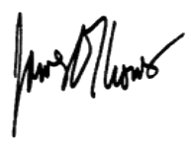
James D. Thomas, MD, FASE
2018 Program Chair

ASE's Promise:
We are the Heart and Circulation Ultrasound Specialists dedicated to improving our patients' health and quality of life. We use ultrasound to provide an exceptional view of the cardiovascular system to enhance patient care.

